# Q:1

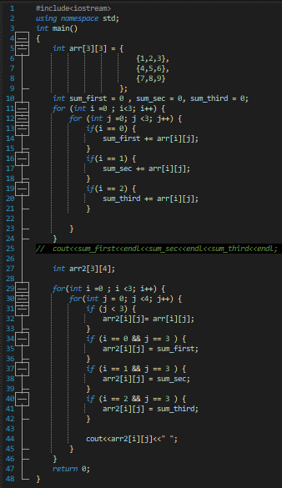

# Q:2

# Q:3

